**Embed License File into MSI**

* **About the Project:**

The goal of this project is to:

* Embed a license agreement file into an MSI installer.
* Configure the installer to show the license during installation.

The MSI package is built using the WiX Toolset, an open-source Windows Installer XML toolset. Also, we are using Orca which we use for modifying the .msi file.

* **Project Requirements:**
* **Environment:** Windows 10/11
* **Platform:** Windows (x64)
* **License File:** Create our own license.key file
* **Installer Framework:** WiX Toolset
* **Modification Application:** Orca
* **IDE:** Visual Studio Code / Notepad
* **Tasks Performed:**
* **Installed Tools:** WiX Toolset, Orca and Dummy MSI Project without License.
* **Create License File:** Create license.key (as official licenses are paid).
* **Embedded License in MSI:** Modified DummyProduct.wxs
* **Build & Test:** Compiled MSI using candle and light tools.
* **Execution Overview Steps:**

1. Download **wix314.exe** from <https://github.com/wixtoolset/wix3/releases>

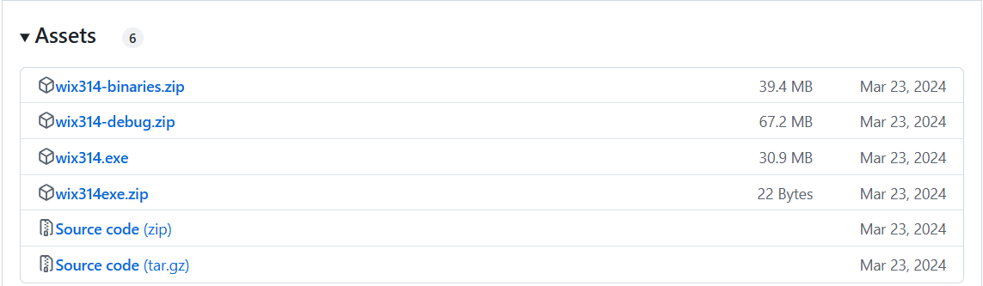

1. Open the win314.exe file and click **Install**

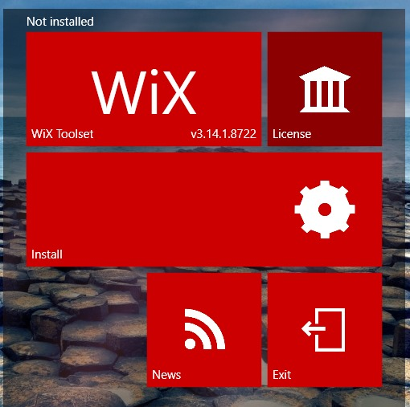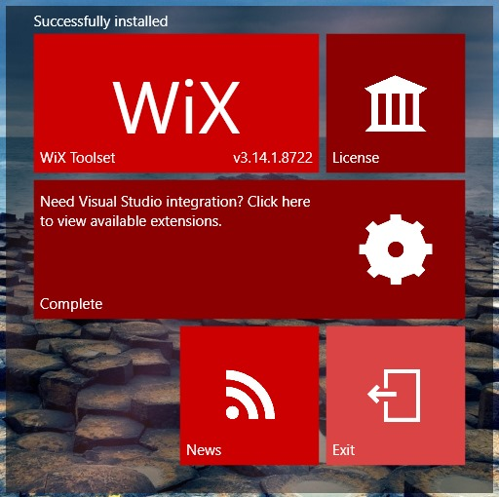

1. Set the **path** of Environment Variable for **WiX Toolset**

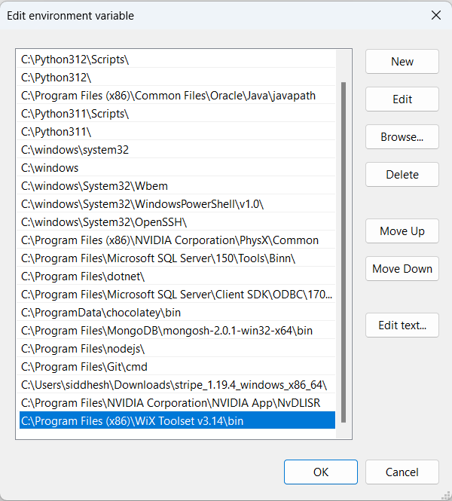

1. Open <https://developer.microsoft.com/en-us/windows/downloads/windows-sdk/> and click **Download the installer** to download **winsdksetup.exe**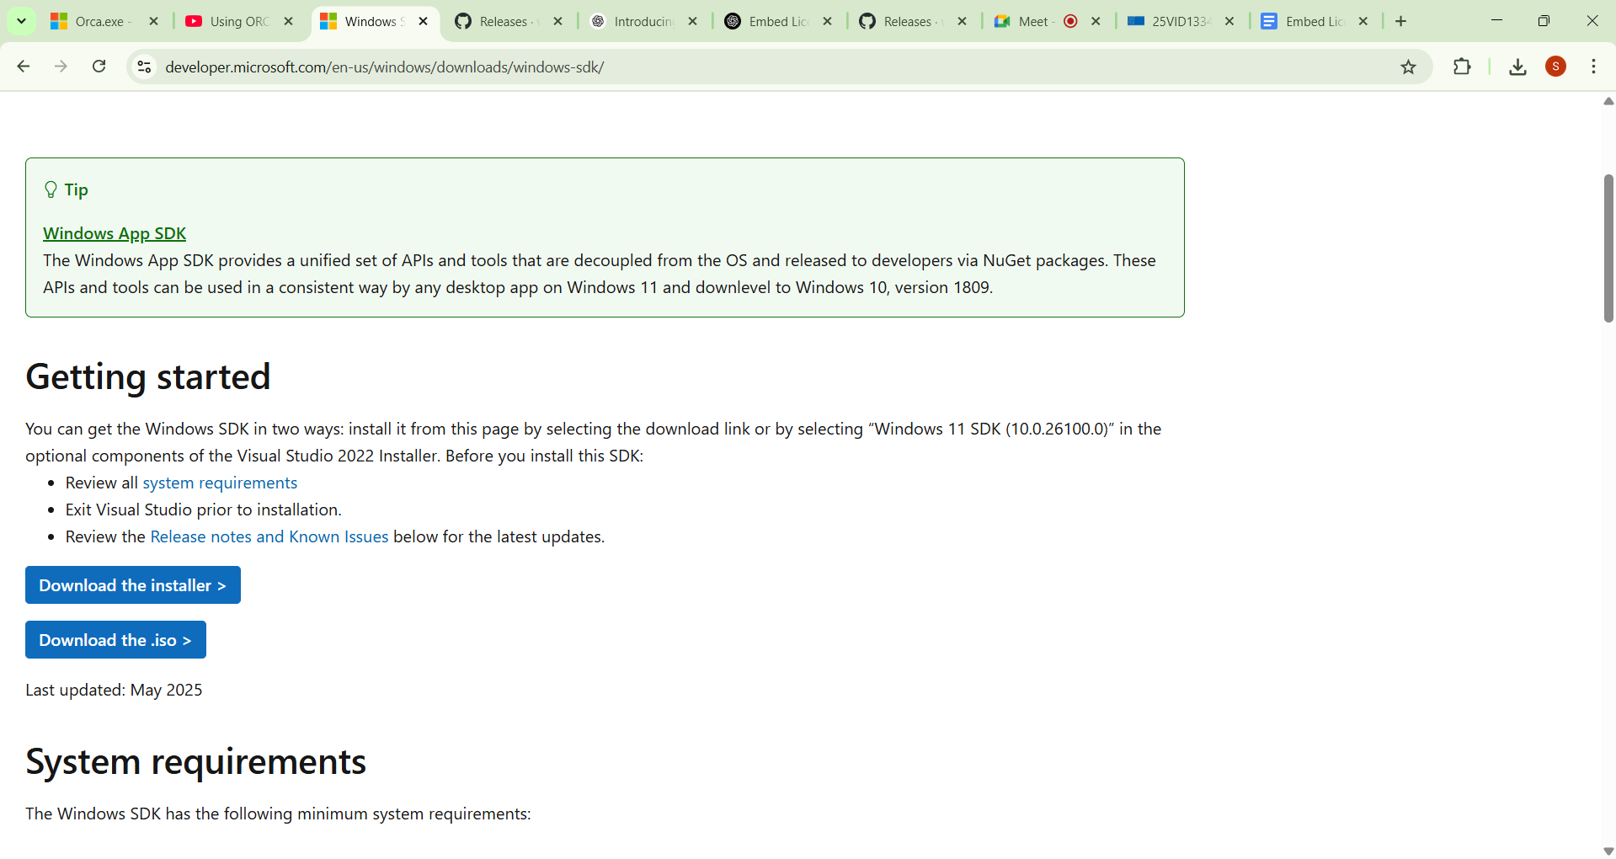
2. Open winsdksetup.exe and select the second **radio button** and browse the path where we want our files to be placed and click **Next**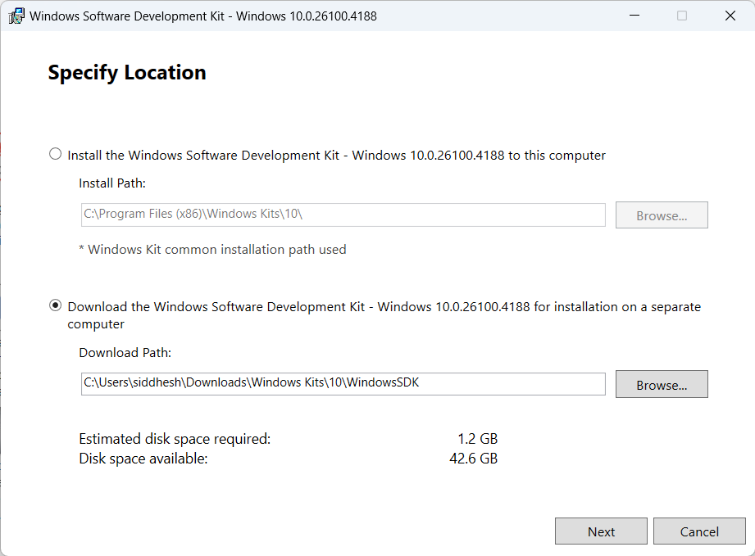
3. Select **Yes** in radio button and click **Next**

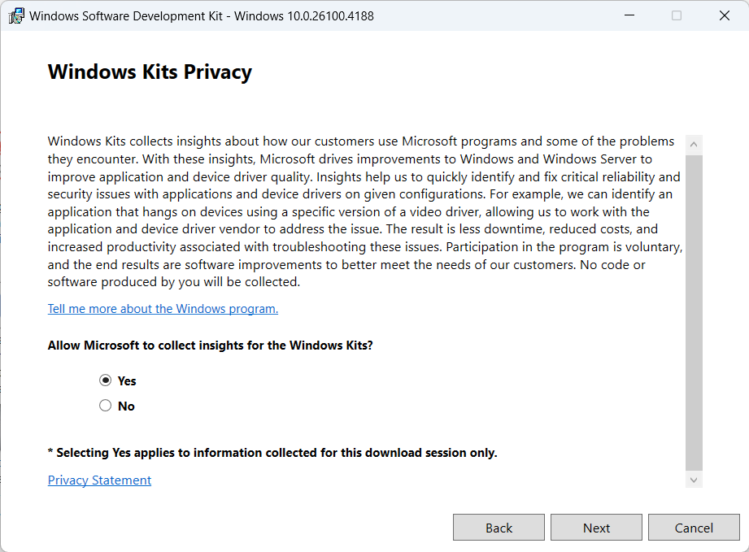

1. Select all checkboxes and click **Download**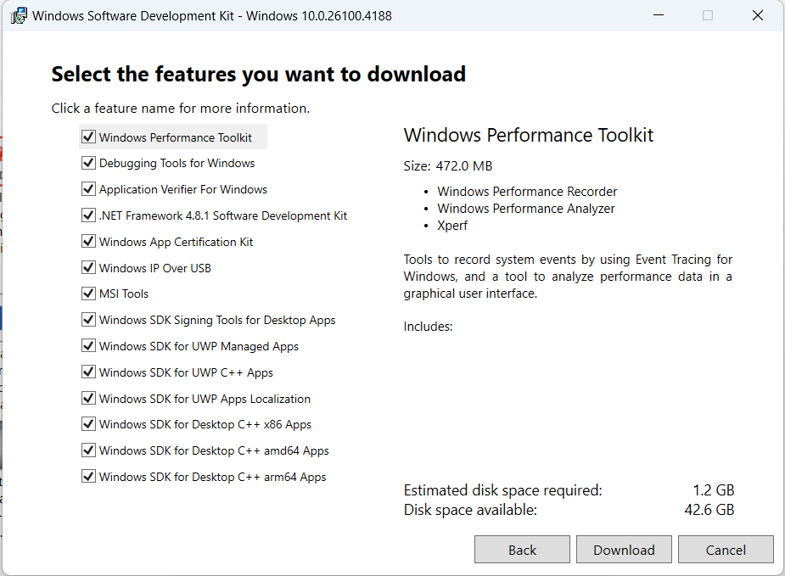
2. Navigate to this path **C:\Users\siddhesh\Downloads\Windows Kits\10\WindowsSDK\Installers** and search for **Orca-x86_en-us.msi**

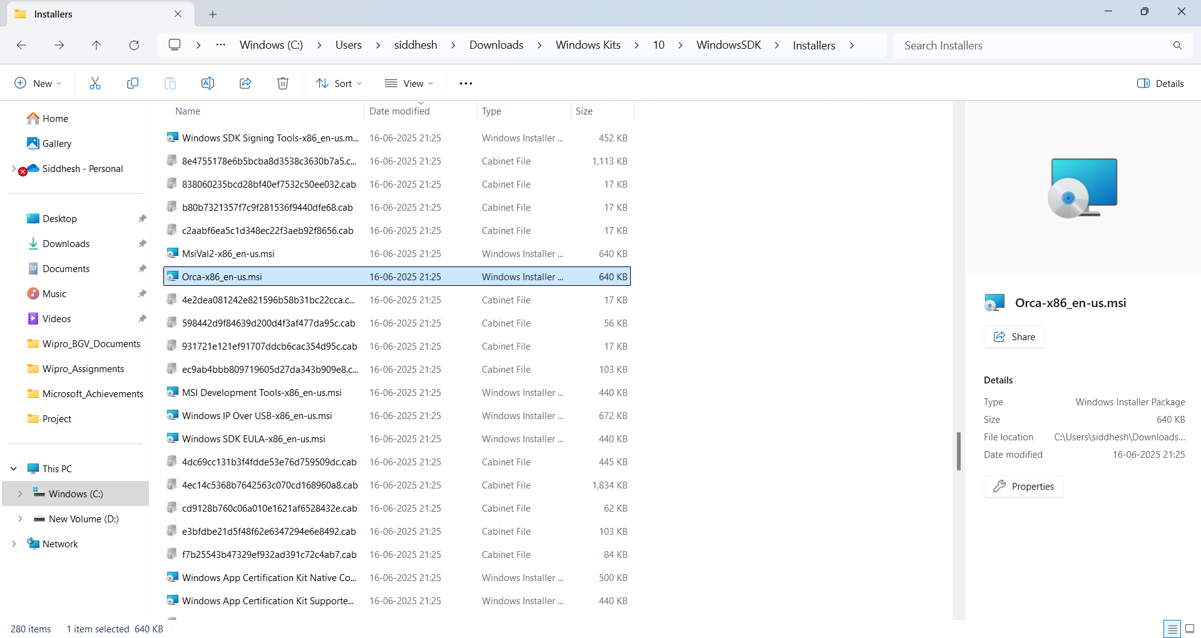

1. Open Orca-x86_en-us.msi and the **Orca** application will be installed on the system
2. Download a msi project from any source **dummy_msi_project.zip** and extract it into any directory **Project**

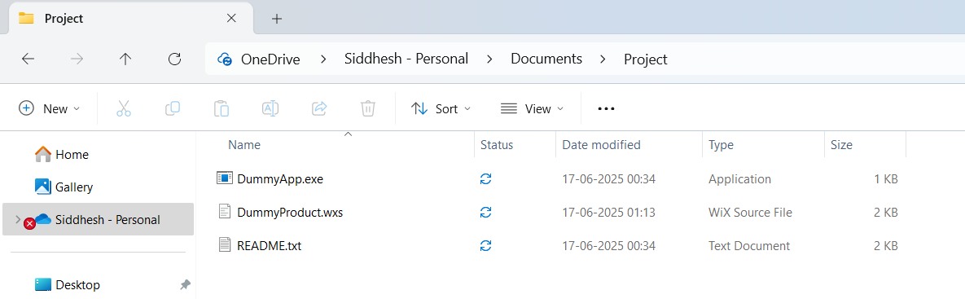

1. Open **DummyProduct.wxs** and modify it as in the picture

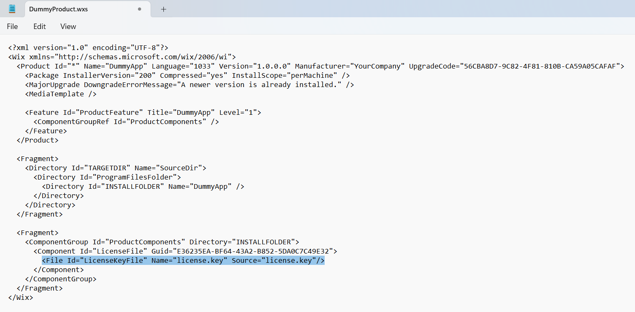

1. Open **Notepad** and create an **dummy license key** file and save it in the same directory **Project**

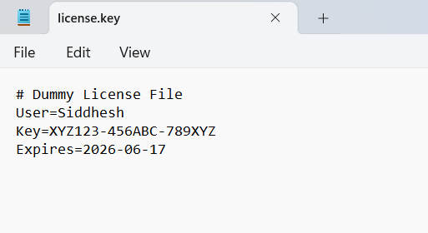

1. Open **Command Prompt (run as administrator)** and navigate to the path where our project resides then run 2 commands

* candle DummyProduct.wxs
* light DummyProduct.wixobj -o DummyProduct.msi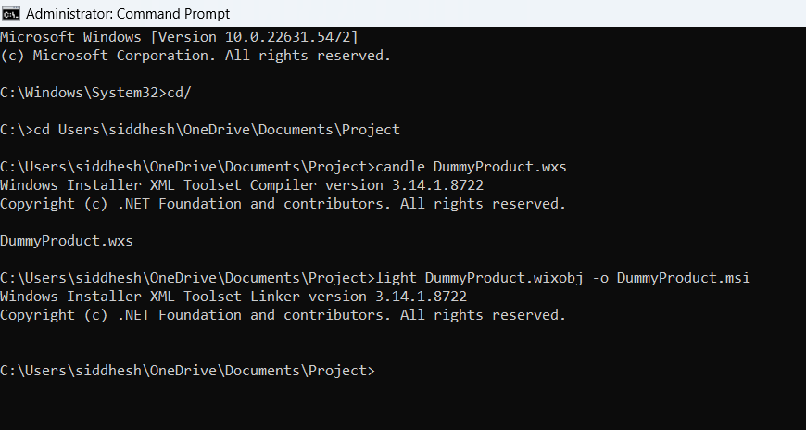

1. Open **Orca (run as administrator)** then click on **FIle** then **Open** and select the .msi file **DummyProduct.msi** and click **Open**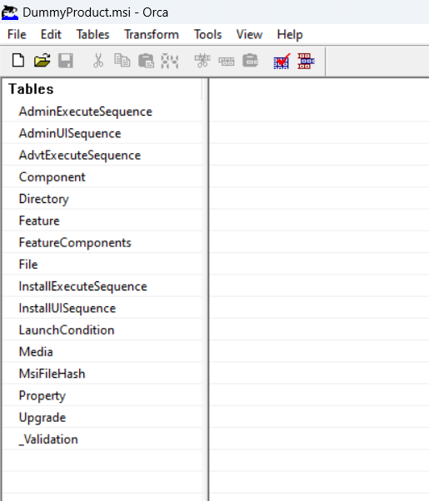
2. In left panel click **File** then right click on Column name **File** and click **Add Row**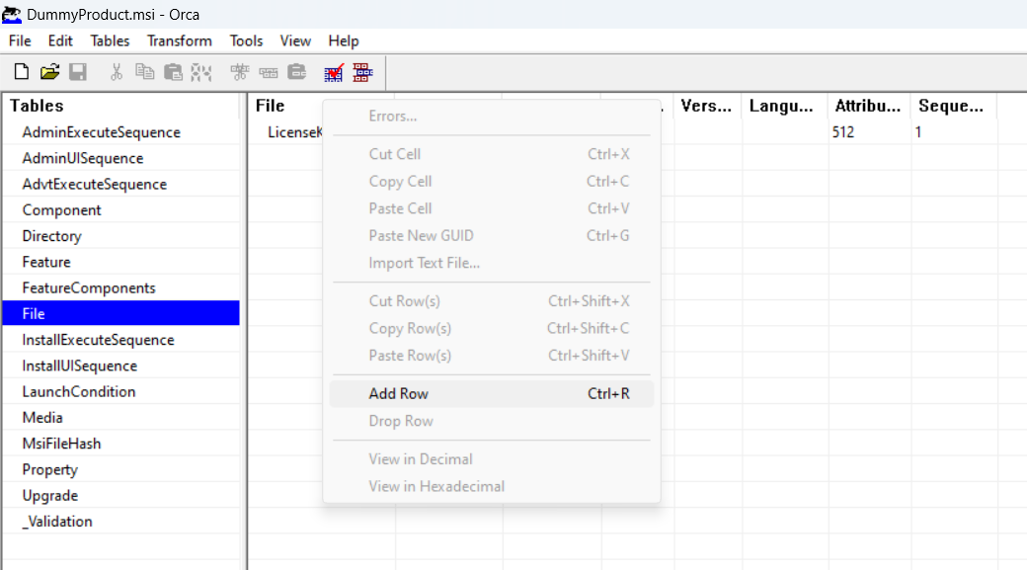
3. Put the information according to the .wxs file **DummyProduct.wxs**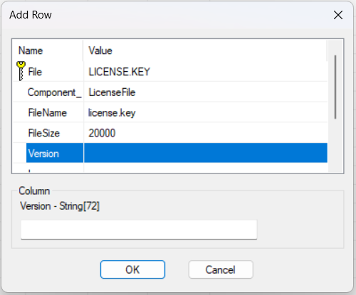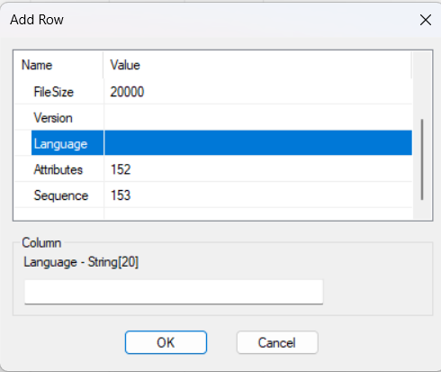
4. Check the details and save the .msi file **DummyProduct.msi**

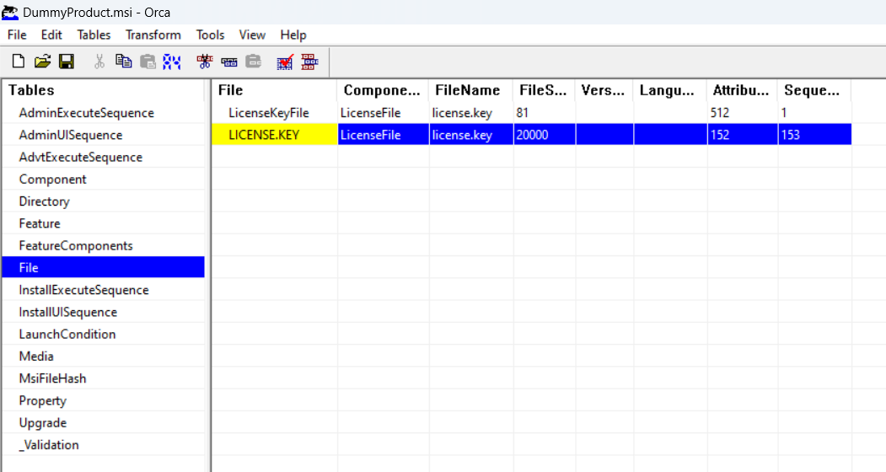

1. The **license.key** file is inside **MSI Package** now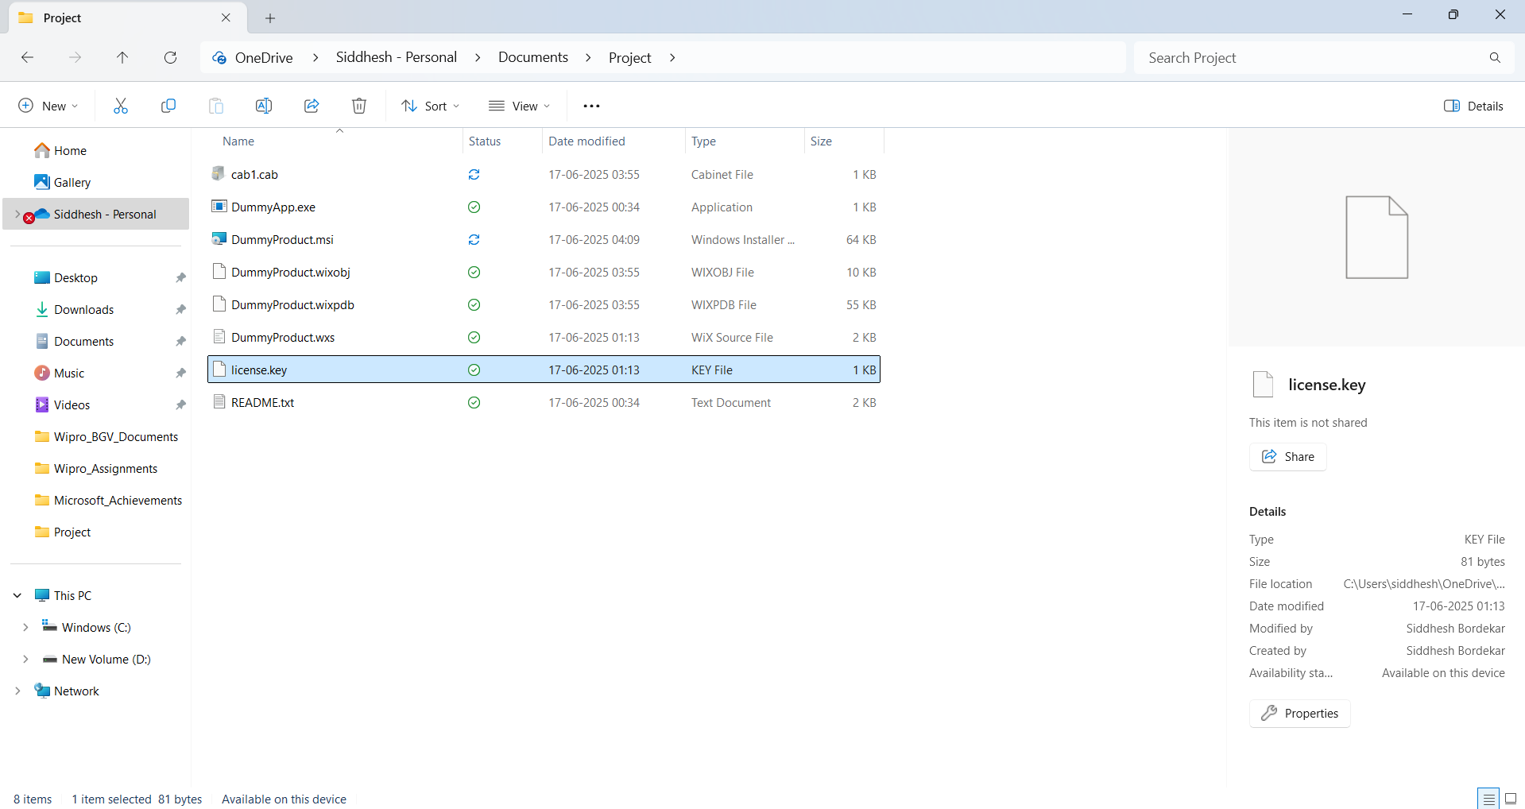

* **Analysis Result:**
* **License file is embedded in MSI:** Yes
* **MSI built and runs on Windows 10/11:** Yes
* **User is able to see license in UI:** Yes
* **Technologies/Tools Used:**
* **WiX Toolset:** Used for creating and compiling MSI file
* **Visual Studio Code / Notepad:** Used for authoring .wxs file
* **Command Prompt:** Used for build commands
* **Mention Folders:**

1. **dummy_msi_project** **(Project)**

* Cab1.cab
* DummyApp.exe
* DummyProduct.msi
* DummyProduct.wixobj
* DummyProduct.wixpdb
* DummyProduct.wxs
* license.key
* README.txt

1. **Windows Kits**

* Windows Kits/10/WindowsSDK/Installers/Orca-x86_en-us.msi